# Rossmoyne Senior High School

### Year 11 Examination, 2015

### Question/Answer Booklet

**SOLUTIONS**

# MATHEMATICS

# SPECIALIST

# UNITS 1 AND 2

## Section Two:

## Calculator-assumed

|  |  |  |  |  |  |  |  |  |
| --- | --- | --- | --- | --- | --- | --- | --- | --- |
| Student Number: In figures |  |  |  |  |  |  |  |  |

In words

Your name

## Time allowed for this section

Reading time before commencing work: ten minutes

Working time for this section: one hundred minutes

## Materials required/recommended for this section

##### *To be provided by the supervisor*

This Question/Answer Booklet

Formula Sheet (retained from Section One)

##### *To be provided by the candidate*

Standard items: pens (blue/black preferred), pencils (including coloured), sharpener,

correction fluid/tape, eraser, ruler, highlighters

Special items: drawing instruments, templates, notes on two unfolded sheets of A4 paper, and up to three calculators approved for use in the WACE examinations

## Important note to candidates

No other items may be taken into the examination room. It is **your** responsibility to ensure that you do not have any unauthorised notes or other items of a non-personal nature in the examination room. If you have any unauthorised material with you, hand it to the supervisor **before** reading any further.

## Structure of this paper

|  |  |  |  |  |  |
| --- | --- | --- | --- | --- | --- |
| Section | Number of questions available | Number of questions to be answered | Working time (minutes) | Marks available | Percentage of exam |
| Section One:  Calculator-free | 8 | 8 | 50 | 52 | 35 |
| Section Two:  Calculator-assumed | 13 | 13 | 100 | 98 | 65 |
|  | | | **Total** | 150 | 100 |

## Instructions to candidates

1. The rules for the conduct of examinations are detailed in the school handbook. Sitting this examination implies that you agree to abide by these rules.
2. Write your answers in this Question/Answer Booklet.
3. You must be careful to confine your response to the specific question asked and to follow any instructions that are specified to a particular question.
4. Spare pages are included at the end of this booklet. They can be used for planning your responses and/or as additional space if required to continue an answer.

* Planning: If you use the spare pages for planning, indicate this clearly at the top of the page.
* Continuing an answer: If you need to use the space to continue an answer, indicate in the original answer space where the answer is continued, i.e. give the page number. Fill in the number of the question that you are continuing to answer at the top of the page.

1. **Show all your working clearly**. Your working should be in sufficient detail to allow your answers to be checked readily and for marks to be awarded for reasoning. Incorrect answers given without supporting reasoning cannot be allocated any marks. For any question or part question worth more than two marks, valid working or justification is required to receive full marks. If you repeat any question, ensure that you cancel the answer you do not wish to have marked.
2. It is recommended that you **do not use pencil**, except in diagrams.
3. The Formula Sheet is **not** to be handed in with your Question/Answer Booklet.

Section Two: Calculator-assumed (98 Marks)

This section has**thirteen (****13)** questions. Answer **all** questions. Write your answers in the spaces provided.

Working time for this section is 100 minutes.

Question 9 (6 marks)

The work done, in joules, by a force F Newtons in changing the displacement of an object s metres is given by the scalar product of F and s.

(a) Determine the work done by a force of 200 N that moves an object 2.7 m, given that the force acts at an angle of 17º to the direction of movement. (1 mark)



(b) When an object is moved  m by a force of 130 N, the work done is 126 J.

(i) Show that one possible force is  N. (2 marks)



(ii) Another possible force is  N. Determine the values of x and y. (3 marks)



Question 10 (7 marks)

On the axes below, triangle ABC is transformed to A'B'C' by a linear transformation.

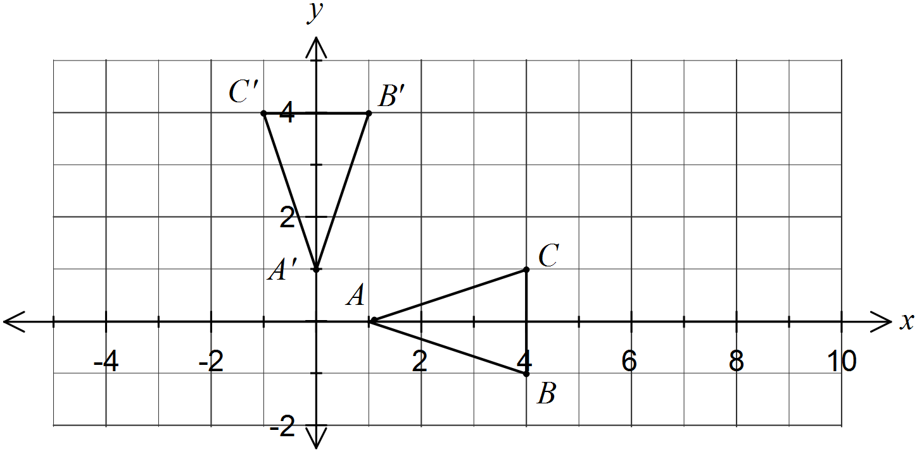

(a) State the appropriate transformation matrix. (1 mark)



(b) Following a second transformation, A'(0, 1) and B'(1, 4) are transformed to A''(0, 2) and B''(3, 8).

(i) Determine the matrix for this second transformation. (2 marks)



(ii) Calculate the area of triangle A''B''C". (2 marks)



(c) Determine the transformation matrix that will transform triangle A''B''C'' back to ABC.

(2 marks)



Question 11 (8 marks)

(a) In the diagram below $∠AEC=85°$ and $∠BAC=38°$. Determine the size of $∠ADB$.

(3 marks)

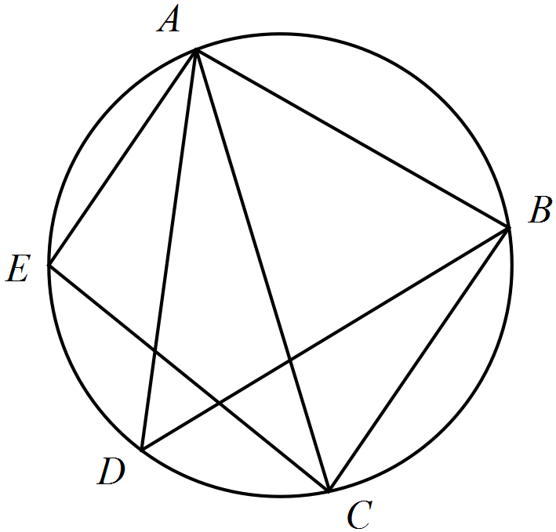



(b) In the diagram shown below, not drawn to scale, a circle with centre O has tangents at E and C that meet at B. If the length of BC is 8 cm and the length of AE is 9 cm, determine the length of DC. (5 marks)

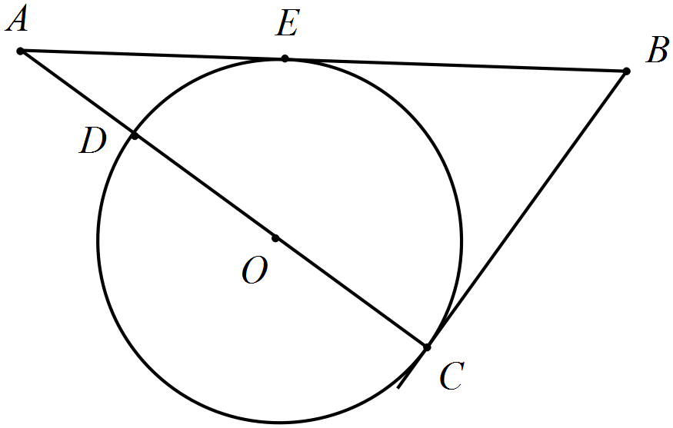



Question 12 (9 marks)

Let  and .

(a) Given that , determine the value of k. (2 marks)



(b) The equations  and  can be expressed as a matrix equation in the form .

(i) State the matrices X and C. (2 marks)



(ii) Write down a matrix equation to determine X in terms of B and C. (2 marks)



(c) Determine the matrix D, if . (3 marks)



Question 13 (6 marks)

(a) Determine the angle between the vectors  and . (2 marks)

Using CAS, 

(b) Determine the value of a so that the vectors  and  are perpendicular.

(2 marks)



(c) Determine the exact scalar projection of  on . (2 marks)



Question 14 (9 marks)

(a) The graphs of $y=f(x)$ and $y=g(x)$ are shown below for .

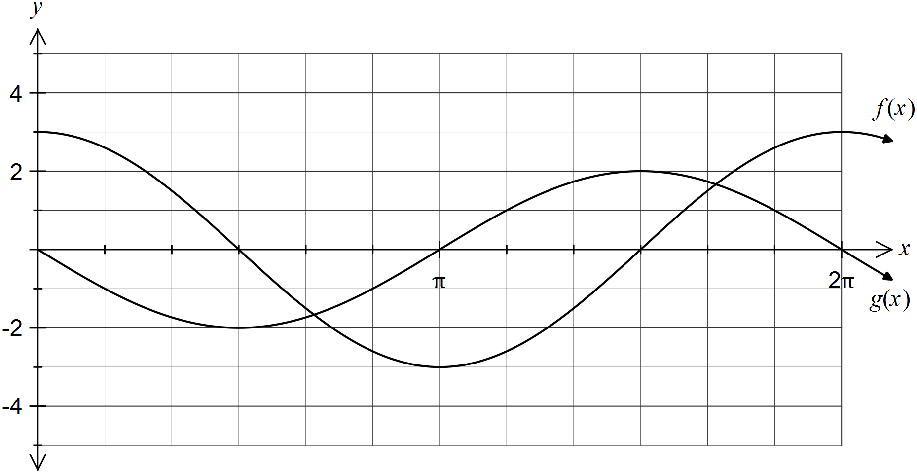

(i) If $f\left(x\right)=a\cos{x}$ and $g\left(x\right)=b\sin{x}$, state the values of a and b. (1 mark)

$$a=3$$

$$b=-2$$

(ii) If $h\left(x\right)=f\left(x\right)+g(x)$ express $h(x)$ in the form $R\cos{(x+α)}$. (3 marks)



(b) The clearance, h metres, under a bridge spanning a river estuary varies with the time since midnight, t hours, and is given by .

(i) Sketch the graph of the clearance against time on the axes below. (3 marks)

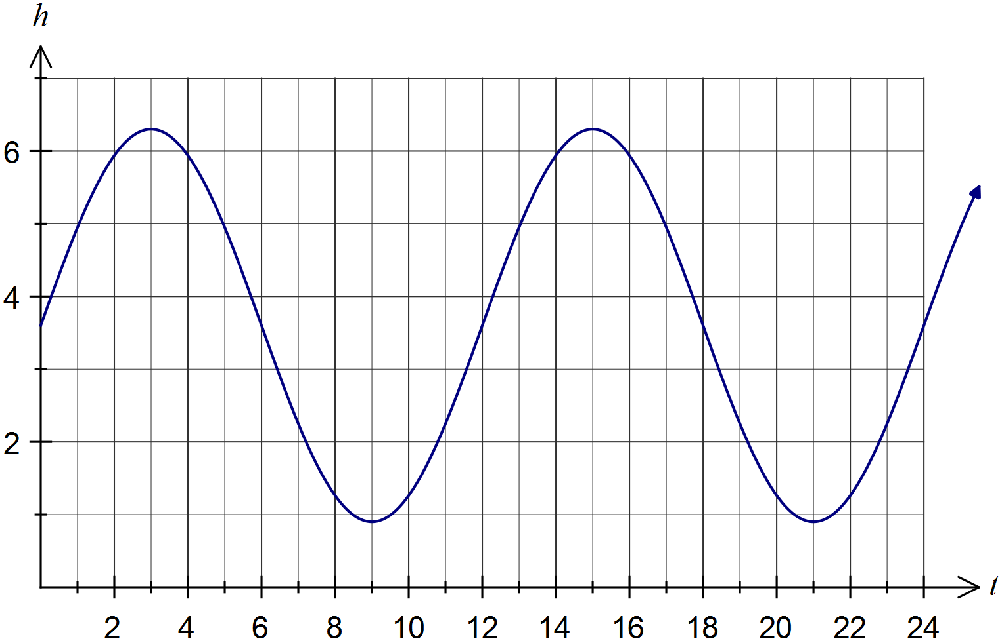

(ii) Determine the percentage of any 24-hour period during which the clearance under the bridge is no more than two metres. (2 marks)



Question 15 (8 marks)

(a) A committee of eight people is to be selected from 10 junior, 14 adult and 11 senior nominations from the members of a club. Determine the number of ways the committee can be selected if

(i) there are no restrictions. (1 mark)



(ii) there must be five adults and more seniors than juniors. (3 marks)



(b) Six books are to be selected for promotion in a newsletter from a choice of nine crime, seven fantasy and six romance novels. Determine the number of selections that include three fantasy or three romance novels. (4 marks)



Question 16 (7 marks)

A cyclist pedals at a speed of 25 km/h along a road on a bearing of 300º. Relative to the cyclist, the wind appears to be blowing from 280º with a speed of 30 km/h.

(a) Sketch a labelled diagram to show the relationship between the velocities of the cyclist, the wind and the wind relative to the cyclist. (2 marks)

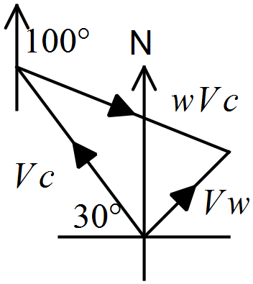



(b) Express the velocities of the cyclist and the wind relative to the cyclist in the component form, rounding coefficients to two decimal places. (2 marks)



(c) Determine the true speed of the wind and the bearing from which it is blowing. (3 marks)

Or using CAS to solve triangle





Question 17 (6 marks)

(a) Show how to express $5.\overline{25}$ as a rational number. (2 marks)



(b) Prove by contradiction that  is an irrational number. (4 marks)



Question 18 (9 marks)

(a) Figure *ABCD* is a parallelogram. Let $\vec{AB}=$**b** and $\vec{AD}=$**d**. Prove that the diagonals *AC* and *BD* are perpendicular only when |**b|**  |**d|**. (4 marks)

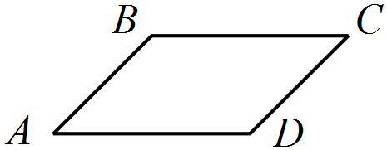



(b) Figure  is a trapezium, with  parallel to  and . If  is the point of intersection of  and, $\vec{OP}=$**p**, $\vec{OR}=$**r**, $\vec{OM}=λ\vec{OQ}$ and $\vec{RM}=μ\vec{RP}$ show that $\vec{OM}=\frac{1}{4}r+\frac{3}{4}p$. (5 marks)

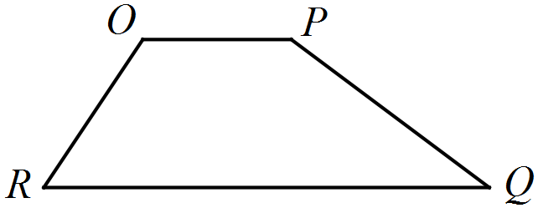



Question 19 (8 marks)

(a) Solve . (2 marks)



(b) The complex numbers $w_{1}$ and $w_{2}$ are shown in the Argand plane below.

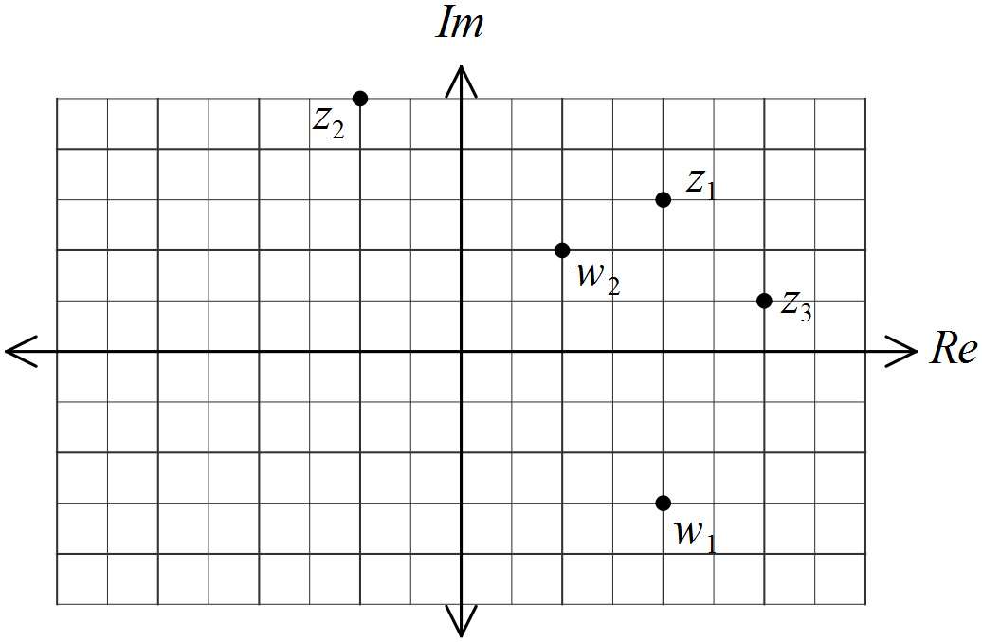

Plot and label the complex numbers given by

(i) $z_{1}={\overline{w}}_{1}$. (1 mark)

(ii) $z_{2}=w_{2}-w_{1}$. (1 mark)

(iii) $z_{3}=\overline{w_{1}+w_{2}}$. (1 mark)

(c) One solution of the quadratic equation  is . Determine the values of the real coefficients b and c. (3 marks)



Question 20 (8 marks)

The points P, Q, R and S lie on a circle of radius r. PR and QS meet at A. PQ and SR are produced to meet at B, and AQBR is a cyclic quadrilateral.

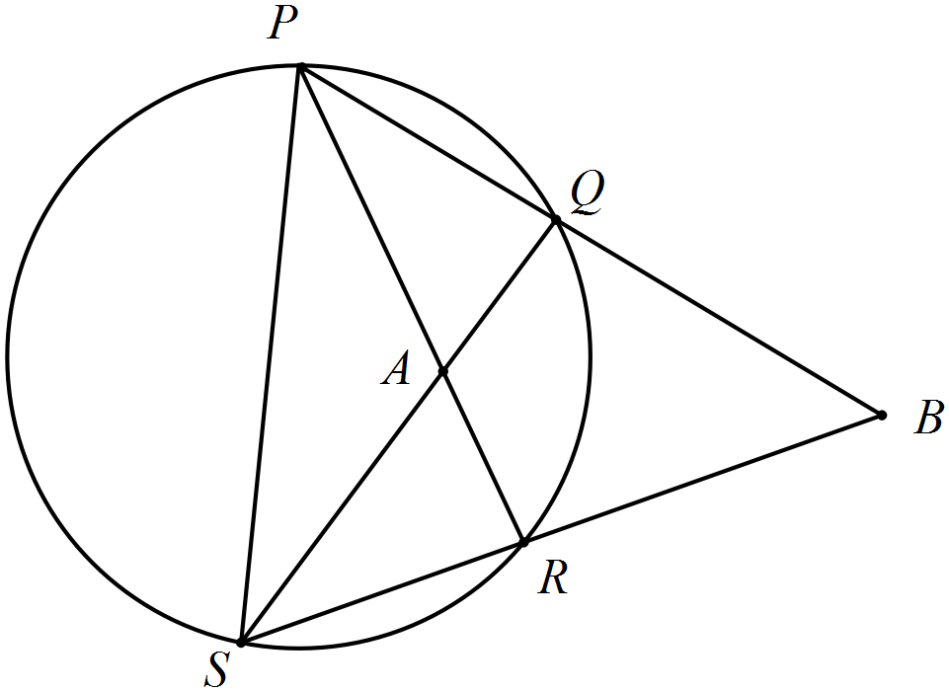

(a) Prove that BS is perpendicular to PR. (6 marks)



(b) Prove that the length of PS is 2r. (2 marks)



Question 21 (7 marks)

Let .

(a) If and , evaluate a and b. (2 marks)



(b) Prove by induction that  is always a multiple of nine when n is a positive integer.

(5 marks)



Additional working space

Question number: _________

Additional working space

Question number: _________

Additional working space

Question number: _________

This examination paper may be freely copied, or communicated on an intranet, for non-commercial purposes within educational institutes that have purchased the paper from WA Examination Papers provided that WA Examination Papers is acknowledged as the copyright owner. Teachers within Rossmoyne Senior High School may change the paper provided that WA Examination Paper's moral rights are not infringed.

Copying or communication for any other purposes can only be done within the terms of the Copyright Act or with prior written permission of WA Examination papers.

*Published by WA Examination Papers*

*PO Box 445 Claremont WA 6910*